(Approx. 3008 words)

President's Corner
Forty Years
By Greg Skalka, President, Under the Computer User Group, CA
June 2019 issue, Drive Light
www.uchug.org
president (at) uchug.org

There have been a lot of changes in the technology that affects our everyday lives over the last 40 years. Personal computers, cell phones, the internet and web sites are just a few of the things we probably use every day that were not around when our user group started. So many technologies have improved so much since then that our lives have been forever changed. Wireless communications, small and powerful batteries, robotics and automation and the ultra-miniaturization of electronics have altered our world economy and our personal behaviors. Our cars, homes, neighborhoods and workplaces have been transformed in many ways. How we get our entertainment, find jobs, search for a mate, order food, pay our bills and communicate with our friends and family have been changed in ways we usually don’t think about much.

A couple of recent events in my life have pointed out some of the ways my life and lives of everyone I know have changed due to the advances in technology in the last 40 years. I recently had to change jobs, due to lay-offs at my longtime employer. In spite of the claimed improved economy and employment situation, I was very concerned about how long my job search might take, as I know there is age discrimination in the workplace (good luck proving it, though). I also had not had to look for a job in almost 20 years and found the employment search landscape had changed considerably. While resumes are still important, including key search terms in them is critical to getting noticed by employers. Most of the searching and applying is now done online, on company web sites and new job search sites like LinkedIn, Indeed and Glassdoor. Even applying for state unemployment benefits is best done online. California has its own job search web site, CalJOBS. Job seekers must post their resumes on the CalJOBS site as a condition of eligibility for unemployment compensation (though I believe it is possible to mail them a resume for posting). Fortunately, due to some old-fashioned networking with ex-coworkers now at other companies, I was able to find new employment relatively quickly.

My son got married a few days ago. While a lot of young people are not including marriage as part of their relationship plans, those that do are involving more technology. While my son’s wedding invitation did involve a mailed card, most of the information and the RSVP capability were on the web site it referenced. The boutonniere I wore as father of the groom had real flowers but was held to my lapel by very small and powerful rare earth magnets, rather than a pin.

Those born in the last 40 years have grown up with all this new technology and have more easily adapted and accepted it. Some of us older folks have had a harder time. That is a major reason why user groups like ours are in decline. Young people see no need for organizations geared towards helping learn and use new tech, leaving a shrinking population of older users that still find them of value. The only exceptions seem to be groups aimed at robotics and ‘maker’ tech, which probably seem way beyond those just looking to solve their email and smart phone problems.

Our Past

In 1979, some San Diegans interested in new technology decided to form a group to help each other and collectively increase their knowledge in the new field of personal computing. In those days only the truly avid hobbyists pursued this interest. Institutional analog and digital computers had existed for some time, but it was the developments of the transistor, solid-state electronics and the integrated circuit that allowed the creation of computing devices that individuals could afford. These early digital computers were often initially available only in kit form, and this particular group favored kits made by the Heath Company, long a supplier of kits for amateur radios, test equipment, television and audio electronics.

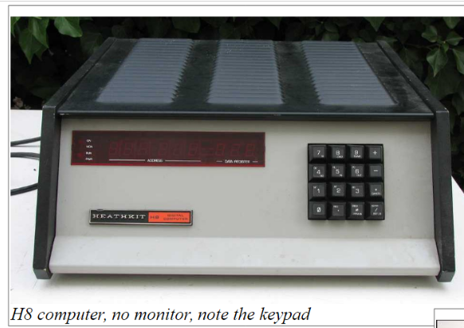
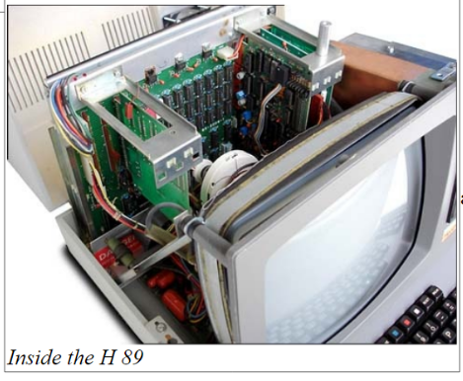
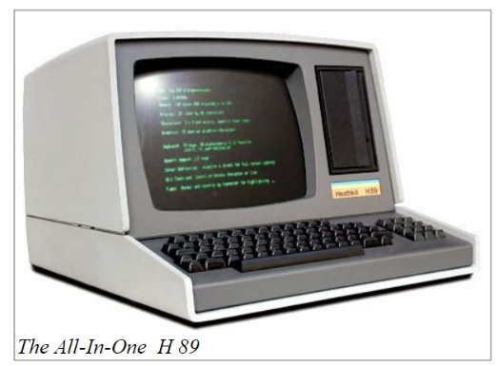
The San Diego Heath User’s Group (SDHUG), as they were originally named, was one computer. They met for a time in the Heathkit store in La Mesa. A computer enthusiast at the time found it difficult to learn about computers and solve their own problems without a user group to help them. Remember that the commercial Internet was still a decade away. There were dial-up BBSes (bulletin board systems), but those required working terminal hardware and software and a sophisticated user. In those days, your display was a few rows of lights or if lucky, a green CRT. Input was by rows of switches or perhaps a keyboard. Computer data storage drives were floppy and were both large in size (8 inch) and small in capacity (about a megabyte). Still, these computers were useful, and our group’s membership grew.

We have a pretty good collection of our group’s newsletters archived on our website, going all the way back to the June 1980 issue, with a few missing here and there from the early years. I started going through our old newsletters last fall, with the intent of writing up what history I could from the information in those first issues. While we have two charter members presently on our membership list as active members (and also serving as board members), I was barely part of that first decade of operation. I did not join the group until March of 1989, and so wanted to research what went on in those early years before I found out about the group. I wrote three columns on my interpretation of our first decade of operation; these appeared in our August, September and October 2018 newsletter issues. Unfortunately, I only got up to January 1983 in my historical review. I’d hoped to finish writing up at least that first decade before our 40th celebration, but with luck I’ll find an opportunity to continue later this year.

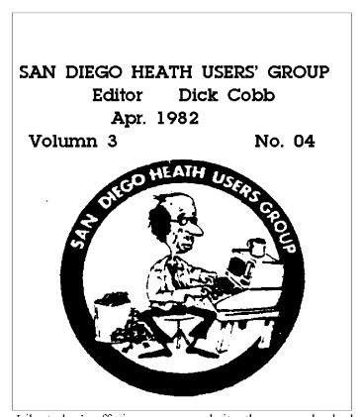
Those early newsletters revealed that a lot has changed over the years but a lot has also stayed the same. Our initial membership count was 27, and our cost of membership was $10. Jim Quinn was the founding President; he is currently serving as our Vice President. Though Jim left the group for a while during his working years, that he has come back once retirement provided him the time to join and serve on our board again is remarkable. Mike Trempe, our present Treasurer, is another Charter member of SDHUG still involved and serving after 40 years!

One of Jim’s reports from an early issue said, “Having received no other nominations for club officers, the following is the ballot we will vote on at the September meeting." Sound familiar? In those early years they also had elections of officers with no contested positions. Even worse than today, the board members sometimes served double duty, as that slate included a President, Vice President/Treasurer, Secretary/Membership, Librarian, Editor and one Member at Large (six board members in total).

Like today’s offerings on our website, the group also had software it provided as a service to its members. In 1981, it included games, personal accounting and income tax software and programming and printing utilities. All these benefits must have been enticing to the computer geeks of those days, as the September 1981 newsletter listed the addition of eight new members from the previous month (dues were $12 per year at the time). In that first decade of SDHUG, membership swelled to a high of around 175, but declined to around 55 by the time I joined in 1989.

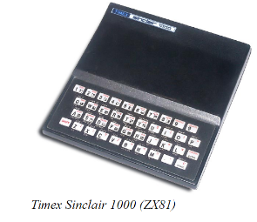
In late 1988, a former co-worker of mine, Bob Woods (our current Webmaster), told me about a group he belonged to that might be able to help with my computer problems. I had been playing with my Timex Sinclair 1000 (ZX81) since the early 80’s and had moved on to the Zenith Z-157, an IBM PC-XT clone. Since Zenith Electronics had acquired Heathkit in 1979 and formed Zenith Data Systems to cater to the computer market, SDHUG had also moved on to help users of ZDS computers and other IBM compatibles. I attended my first meeting in February of 1989 and joined the group the following month. By that time they were meeting at the Kearny Mesa Rec Center.

My involvement in the group started slowly and innocently at first. I wrote a review of a program from the group’s library for their newsletter (August 1990 issue of the now Dup & Dump Lite), and then was asked to run for an Officer-at-Large position on the board in 1991. The board must have seen me coming, as they recruited me to take the minutes of the first board meeting I attended as an officer (see the Nov. 1991 issue). After taking board meeting minutes in the absence of our Secretary at the time, Clem Pepper, for another time (Sept. 1992 issue), I was “recruited” for the Secretary position in the fall of 1992. I would never again escape the board, serving two terms as Secretary, one as Vice President, and finally the top of the slate. So this fall, I will have served 28 consecutive years on the board and 24 consecutive years as President. My work with the group has been made far easier by the core group of key officers who have competently served just about as long.

A number of significant changes occurred in the group since I joined the board. In 1993, with the decline of both the Heath name and our membership numbers, our President at the time, Sandy Shapiro, led the board in discussions on changing our group’s name to something more relevant to the computing landscape of the day. Our December 1993 newsletter was to be the last with the SDHUG logo, as the membership voted at the December general meeting to change to the Under the Computer Hood Users Group, or UCHUG. Note that other names on the ballot were Under The Hood Users’ Group (UTHUG) and Under the Hood Users’ Group (UHUG). Our members made a good choice, keeping a piece of our heritage while expressing our focus on all technical (under the hood) aspects of computer hardware and software. By February 1994, we had also changed the masthead of our newsletter to the more relevant “Drive Lite” (it would later change to the current “Drive Light”).

As S.D. UCHUG, we remained a user group affiliated with the San Diego Computer Society (SDCS). Our relationship with SDCS brought a number of benefits, including booth space at many computer fairs and expos sponsored by SDCS and ComputorEdge. Our expo booths at the San Diego Convention Center proved to be a great place to show off our group and recruit new members. We also were allowed to use the VGA projection pad belonging to the SDCS for our meeting presentations (remember overhead projectors?). Later we were told we could only use their pad while at the San Diego County Office of Education, where the SDCS met, so in September 1994 we moved our general meetings there. This was generally a good meeting location for us, especially when we got to meet in their plush Joe Rindone Technology Center.

In 2003 I attended my first Southwest Computer Conference. Since they were at the time being held in San Diego, we could usually get good representation there by members of our group. At our 2004 picnic we celebrated the group’s silver anniversary. The 25th anniversary edition of the Drive Light that Art Gresham, our long-serving editor, put out that month contained lots of great historical information on our group for the occasion.

Our relationship with the SDCS turned sour later that year when, in decline, the SDCS was effectively taken over by members of SDMUG, the San Diego Macintosh User Group, which was another associated group. This was one of the most difficult times I have seen our group face, but by December of 2004 we were able to settle with the SDCS in a manner acceptable to all. Through the hard work of Peggy Elliott and Al Brengle, we were able to incorporate as a California Public Benefit Corporation and were granted 501(c)(3) Federal tax-exempt status and state tax exempt status in 2005 and were returned our assets held by SDCS. Now SDMUG is still out there (it appears by their Meetup page that they are now a SIG of CyberTECH, another non-profit tech group) and we are still going, but it appears that SDCS is no more.

With SDCS out of the picture we were initially able to continue meeting at the SDCOE facilities for free, but in December of 2008 we were informed that we would be charged (quite a bit!) going forward. Through the help of UCHUG members that also belonged to the Seniors Computer Group, we were able start meeting at the Wesley Palms retirement community in February 2009. We have enjoyed using their wonderful facilities ever since (though due to our reduced size, we were moved from Woodbury Hall to the smaller Activities Room a few years ago).

Our group’s attendance at the Southwest Computer Conference was strong while it was held at the Town & Country Hotel and Convention Center in San Diego, with a dozen or so members able to go each year. Once the conference (then renamed the Southwest Technology and Computer Conference) moved to the Kellogg West Conference Center at Cal Poly Pomona in 2013, the number of UCHUG members that could make the journey dropped to a handful. Unfortunately, overall attendance was also down and 2015 was the last year the conference was held.

UCHUG has for many years (approximately 10) been a member of the Association of Personal Computer User Groups, or APCUG. It is an organization helping groups devoted to technology, providing resources and facilitating communications between groups. Our group has used many live (through video conferencing) and recorded presentations provided by the APCUG Speakers Bureau and their Virtual Technology Conferences (VTC). Through Judy Taylour, a Southwest organizer and APCUG Board of Advisors member, our group was invited to participate in SCRUGS (Southern California Regional User Group Summit), a quarterly meeting of SoCal user group leaders held in the Los Angeles area. I have been attending those meetings for about the last ten years, bringing useful information on presentation sources and dealing with organizational and membership issues back to our board.

In recent years the board has continued to look for ways to attract new members. One way we have tried to get our group’s name out there is through our Meetup page, started a few years ago. Though we have several hundred Meetup “members," this has translated into only a handful of actual new members for the group. The costs for our Meetup membership have so far been covered by generous donations from our Vice President.

Through all the changes our group has gone through over 40 years, we have always provided informative monthly presentations (at least ten months per year), engaging social activities (December parties and June picnics) and mutual help and support through our “random access” problem solving sessions. With our membership in a slow decline, we continue to seek new ways to stay relevant. With our members interested in new technologies like smart phones, smart homes and tablet computers, we have added more presentations in those areas.

Our Future


Over the years, prudent management and fortunate meeting room arrangements have kept the group on a solid financial footing. Our main problem is the same as most groups in APCUG - a declining (and aging) membership. I would have liked to research our group’s membership numbers over the years and be able to provide a graph, but never found the time. Most APCUG groups report problems recruiting members for officer positions, a common issue in volunteer-run organizations. Some groups wind up disbanding due to a lack of volunteers to fill board positions, as groups cannot be run by only a couple of volunteers filling multiple officer positions.

UCHUG has been very fortunate to have a very good group of dedicated and long-serving officers as its board of directors. Our core group of officers - president, secretary, treasurer, editor and librarian/webmaster - have all been serving in those positions for at least 20 years. We have always been able to keep at least nine officers (out of 11) on the board at any time, with all the key positions filled.

We have not been as lucky with total membership, as though we may pick up a new member or two per year, we lose more and have now declined to 21 paid members. With ten of them officers, our board now makes up almost half the group. While we have had some luck in the past attracting younger members, I’m pretty sure we currently don’t have any members under fifty, and many are in their seventies and eighties. We generally do have a pretty good turnout at meetings, though, with 17 reported at our March meeting this year (this is great considering a few of our members live out of the area and don’t ever attend).

Our board has had discussions on what to do when our membership numbers get too low, though we have not defined what too low is. We continue to look for ways to boost membership. More advertising might help, though finding the right method and medium is key. We send our presentation information to Wesley Palms to publicize, but we have never had much luck attracting their residents to our meetings. Still, we will keep trying to provide presentations and benefits of value. As long as we continue to have a strong board made up of hard working and congenial members, they will hopefully steer our group through many more anniversary celebrations.

Happy 40th anniversary to UCHUG!

